Practice Assignment #5
Selection and Repetition

- MazeWalker:
Extend the RobotSE class to create a MazeWalker that will always start at position (0,0) and has only one public method:

public void followRightWall ( )
This method causes the MazeWalker to continue following the wall on its right side, until it gets to the other side of the maze (indicated by a flasher).

followRightWall( ) can make use of other private methods to complete its task. Create a sample maze to test your MazeWalker. When complete, create a "tough" maze and exchange mazes with someone else in the class. Test your MazeWalker on their maze (without modifying your MazeWalker).

Sample Maze: (HINT look up in the Becker docs how to easily create a maze)
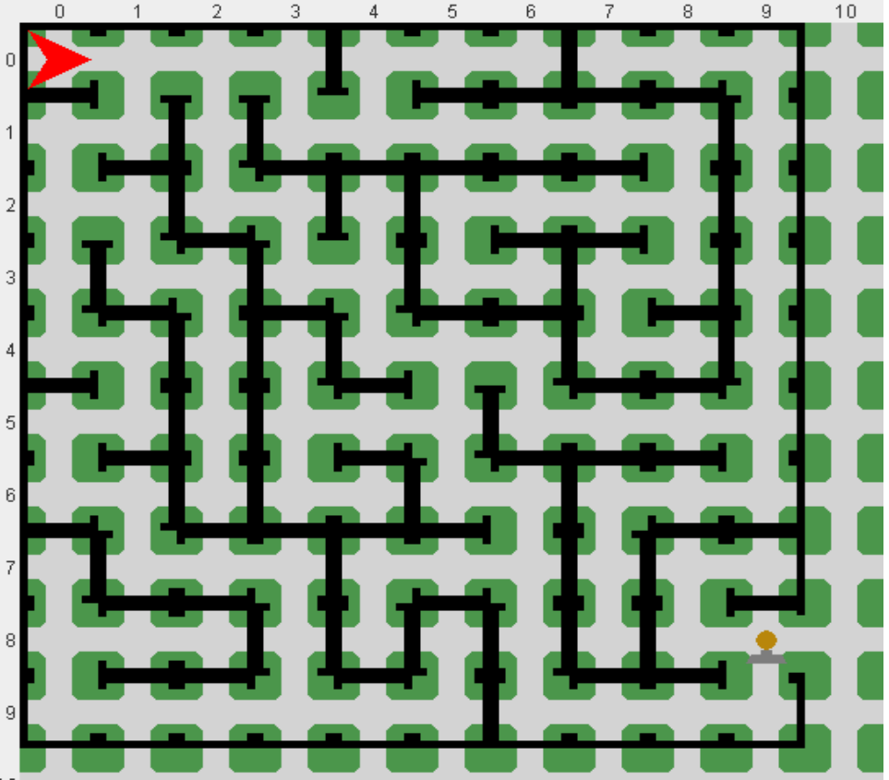

2. The Steeplechaser:
Create a SteepleChaser Robot that extends the RobotSE class. A steeplechase is a type of race where the runner has to jump over barriers of differing heights (see sample diagram):
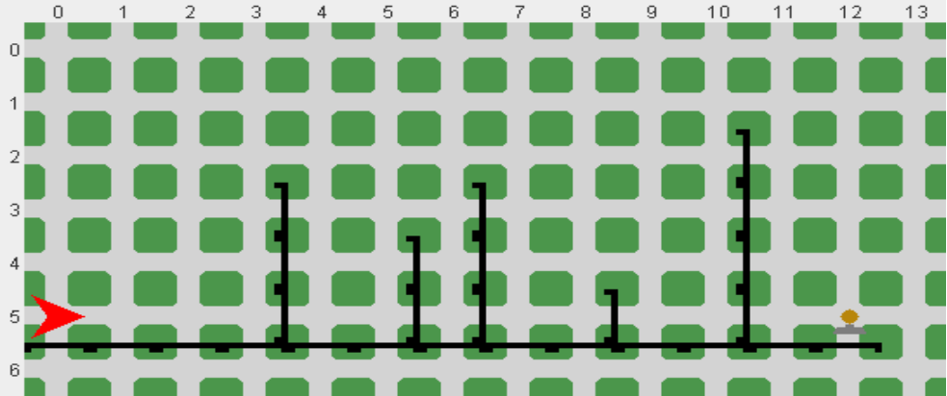
The SteepleChaser must always touch the ground between steeples and has the following methods:

public void runRace( )
Runs the race until the finish line is crossed (flasher)

private void raceStride( )
Moves the SteepleChaser one intersection forward, jumping over any barrier to do so

private void jumpBarrier( )
Jumps a barrier of any height

Feel free to add any other methods as required to improve the readability of your code. Test your SteepleChaser on several different courses.

3. Roomba:
Create a Roomba that is placed at intersection 1,1, which is the top-left corner of a fully enclosed rectangular room of unknown size. There is an unknown amount of “litter” (Things) on each intersection in the room (see sample diagram):
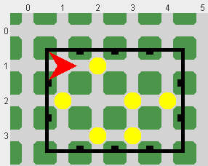

Roomba will clean up all the litter in the room and return to its starting location when complete. Be sure to use proper stepwise refinement when creating your solution.

